Fission Product Decontamination Factors for

Plutonium Separated by PUREX from Low

Burnup, Fast-Neutron Irradiated Depleted UO2

Paul M. Mendozaa,b, Sunil S. Chirayatha,b,*, Charles M. Folden IIIc

*Texas A&M University, College Station, TX 77843-3473*

*aNuclear*  *Security Science & Policy Institute (NSSPI)*

*bTAMU*  *Department of Nuclear Engineering*

*cCyclotron Institute*

**Abstract**

Experimental investigations to determine fission product (FP) separation from actinides (U and Pu) while employing the Plutonium Uranium Recovery by Extraction (PUREX) process to purify plutonium produced in a fast neutron

irradiated depleted uranium dioxide (DUO2) target were conducted. The sample

was a DUO2 surrogate pellet (0.2562 wt.%initial 235U) irradiated to a low-burnup (4.43  0.31 GWd/tHM) that was PUREX processed 538 days after neutron

irradiation. Decontamination factors (DF) for the elements U, Mo, Ru, Ce, Sm, Sr, Pm, Eu, Nd, Pd, Cd, Ba and Sn were measured in two experiments using 30 vol.% tri-n-butyl phosphate in a kerosene diluent. The first experiment characterized Pu DFs for a single contact extraction and back-extraction, while the second experiment had multiple contacts with the goal of achieving greater Pu recovery. The benchtop scale PUREX process had overall Pu recoveries of 76% and 94%, respectively, and had overall activity decontamination factors of 20 and 5 for the first and second experiments, respectively.

*Keywords:* PUREX, Decontamination Factor, Depleted Uranium

*2010 MSC:* 00-01, 99-00

**1. Introduction**

*Background.* In a recent publication, our group suggested that investigation of trace contaminants in plutonium recovered using the Plutonium Uranium Recovery by Extraction (PUREX) process could give indications of

*Corresponding author

*Email address:* sunilsc@tamu.edu (Sunil S. Chirayath)

*Preprint submitted to Journal of Applied Radiation and Isotopes*  *March 28, 2016*

material origins, but that a broad study of many elements would be necessary

5 [1]. Descriptions of various PUREX processes are provided in many sources

[2, 3, 4] with explanations of chemistry including ﬂow sheets and decontamination factors (DFs) [5, 6, 7]. These sources

generally report overall beta or gamma DFs of up to 108 with Pu recoveries of

99.7% for industrial-scale reprocessing facilities. While distribution coefficients (DC) for the various process separation steps

of PUREX have been previously reported, details about elemental DFs for

PUREX cycles have been largely limited to the major activity contributors,

such as

106Ru

and

95Zr

[3]. A compilation of distribution data for PUREX

15

20

extraction processes provide data for U, Th, and Pu in a variety of

concentrations [8]. DCs for Zr, rare earth metals, Pu, and Th are also available

[9, 10, 11, 12, 13, 14, 15].

Although a DC (coupled with process information) can be used to calculate

a reasonable estimate of DF [16, 17, 18, 19], variability of DCs under different

system conditions give rise to uncertainty in calculated results. For example,

DCs between tri-n-butyl phosphate (TBP) and nitric acid (HNO3) have been

reported for U, Pu, Zr, Nb, Ru, and the rare earth elements, but vary with

HNO3 concentration and U saturation in TBP [17, 3]. These sources

also derive mathematical correlations between DC and DF, but experimental

PUREX DFs for a large number of individual elements were not provided. Ad-

25

30

ditionally, Ga has been studied for separation [20] because it is a common

contaminant in weapons-grade Pu.

In the current work, 12.9 mg of depleted uranium dioxide (DUO2) was irradiated in a pseudo-fast

neutron spectrum at the High Flux Isotope Reactor (HFIR) at Oak Ridge National Lab-

oratory. The DUO2 pellet, containing FP and weapons-grade Pu, was dissolved

in HNO3 and subjected to two different PUREX experiments

2

for DF characterization and Pu product recovery. Solutions were analyzed at

each step with Inductively Coupled Plasma-Mass Spectrometry (ICP-MS). The

experimental work used benchtop-scale methods to isolate a large fraction of

Pu, measure DFs for fission products, and measure gamma DFs as part of a

35

larger project to develop forensic radioanalytical capabilities at Texas A&M

University.

*Terminology.* A DC is defined as the concentration ratio between the organic

(org) and aqueous (aq) phases as shown in Equation 1, and describes the

equilibrium distribution of any species in the system during PUREX separation pro-

40

cesses [4]:

*DC* = *ccorg aq*

(1)

where *c* is the concentration of the specific species in the indicated phase.

DCs are specific to an element and vary widely with the concentration and

temperature of the solvents. They are also affected by saturation of uranium

and plutonium in the system and time since preparation of the solution [3, 21].

45 For PUREX, the fraction of mass *forg* deposited in the organic (TBP) phase

for a single element (assuming equal contact volumes) is given by Equation 2.

*forg* = (1 + *DC*−1)−1 (2)

After several cycles of plutonium extraction/decontamination are complete,

the measured effectiveness of a PUREX cycle is described by the DF, which is

fundamentally determined by DCs and measure the effectiveness with which a

50 contaminant, *j*, is removed from a product. In this work, the product of interest

is Pu, and the DF is defined by Equation 3.

3

*cj*

*cP u initial*

*DFj* = (3)

*cj*

*cP u f inal*

Initial and final refer to the values before and after purification, respec-

tively. DFs are also characteristic of different process cycles, and may have

larger values (*>* 107) for industrial scale PUREX compared to the benchtop

55

scale version presented here [3, 4].

Industrial processes report either an overall DF value, or a DF value for a

single isotope. What is needed for forensics purposes is DFs for individual FP

contaminants, which is why elemental DF values were obtained for benchtop-

scale PUREX process performed on a DUO2 surrogate sample.

60 **2. Experiment**

A commercially acquired pellet containing 12.9  0.1 mg of DUO2 was ir-

radiated over the course of three months (with two shutdown periods) in the

HFIR. The final burnup was 4.43  0.31 GWd/tHM [22], and was deter-

mined by measuring the

137Cs

activity. The irradiation produced 0.237  0.008 mg

65

of Pu. After the short lived radioisotopes had opportunity to decay, the irradiated pel-

let was shipped to Texas A&M University.

Samples were prepared as shown in Figure 1, and described below. The sample was

added to a round-bottom flask and 5.0 ml of

8 M HNO3 was added to the ﬂask, which was heated to 50 ◦C with constant 100

rpm stirring for 2 h. This solution will be referred to as the "dissolution

solution". The ﬂask was connected to a cold trap with the help of a Schlenk

line. The fission product gases such as H2, CO2, Kr, Br, I and N2O were

captured in a cold trap containing molecular sieves that were chilled by liquid

4

Figure 1: Flow chart for dissolution.

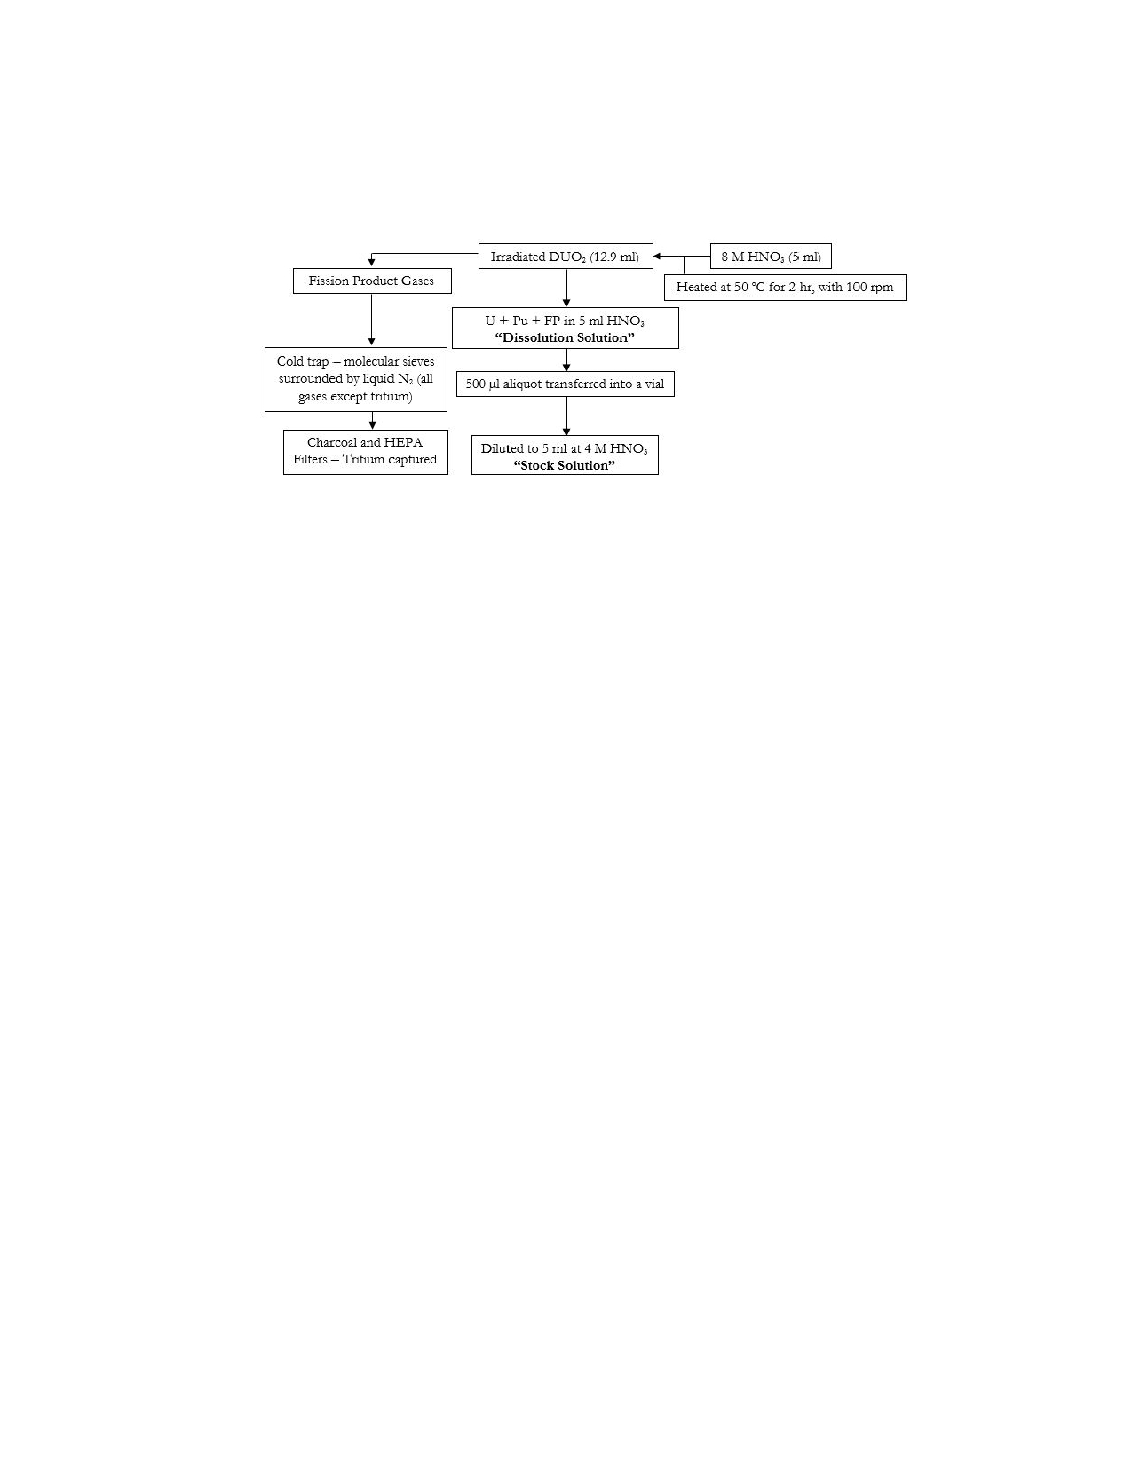

nitrogen. In order to reduce the amount of activity per sample, 500µl from the

dissolution solution was diluted to 5.0 ml and the concentration was changed

to 4 M HNO3. From this solution, referred to as the "stock solution", 0.5 ml

aliquots, containing ∼1% of the pellet, were used in benchtop-scale PUREX

experiments described in the two subsections below. The total activity concentration

of the stock solution was approximately 80µCi/ml.

Experiments started by transferring a 500µl aliquot of stock solution and

70

0.5 mg of NaNO2 to a 15 ml centrifuge tube. The tube was subsequently stirred

and covered to retain the resulting NO2 gas. The solution was left overnight

so that Pu(III) was completely oxidized to Pu(IV). During extraction and

back-extraction, both experiments had the aqueous and organic phases mixed

on a vortex mixer for 15 min at 1500 rpm, after which the two phases were

75

80

allowed to settle and separate. The phases were physically separated into two

different vials through careful pipetting.

Each extraction and back-extraction mixed organic and aqueous mixtures

with unequal volumes. The solution being added always contained an extra 200

µl to reduce the chance of accidentally pipetting HNO3. For example, if TBP

were being added to the stock solution described above, 700µl would be added

5

initially and 500µl removed. This excess volume will be referred to as

hold-up volume.

The kerosene and NaNO2 used for these experiments

were acquired from sciencelab.com [23], 69% nitric acid was acquired from

85

90

Mallinckrodt Chemicals [24], tri-n-butyl phosphate (*>*99%) was acquired from

Fisher Scientific [25], and iron sulfamate (40.26%) was acquired from Strem

Chemicals [26].

The pellet, both prior to dissolution and after, was counted with a Canberra

HPGe detector model number CC4018 which was connected to a Canberra Lynx

multichannel analyzer [27, 28]. Canberra's software package GENIE-2000 version 3.2.1

[29] was

used to collect spectra while the samples were inside a lead tomb. The same detector

was used to count the various process solutions. Inductively coupled plasma

mass spectrometry (ICP-MS) was also conducted for aqueous samples using a

PerkinElmer NexION 300X quadrupole ICP-MS [30].

95

*First Experiment.* The purpose of the first experiment was to quantify product

recovery and DF values for a single contact extraction and back-extraction of

Pu. U(VI) and Pu(IV) were extracted and decontaminated by contacting the

prepared stock solution with a solution of 30 vol.% TBP with a kerosene diluent.

After mixing and separation of the two phases, Pu(IV) was reduced to Pu(III)

100

105

and back-extracted by contacting the physically separated TBP solution with 0.75 M

HNO3

in a 0.024 M ferrous sulfamate solution via oxidation of Fe(II). The stock solution

both before and after TBP contact, as well as the final solution containing back-

extracted Pu, were analyzed with ICP-MS.

*Second Experiment.* The purpose of the second experiment was to extract a

large fraction of Pu. Utilizing the results from the first experiment, it was

determined that contacting the prepared stock solution four times with TBP

would extract over 90% of the Pu. Therefore, this experiment had four TBP

6

contacts with the prepared stock solution. The four TBP solutions was then collected into

a single vial, and contacted three times with the ferrous sulfamate solution. In order to

ensure minimal U back-extraction, the HNO3 concentration for

this experiment was increased to 4 M because higher concentrations reduce the degree to which

U is back-extracted [3]. Three contacts of the ferrous sulfamate solution ensured

complete back-extraction of Pu, while the higher nitric acid concentration min-

115

imized back-extraction of U. The same solutions as described in the first ex-

periment were analyzed with ICP-MS. The final back-extracted Pu solution

underwent the four extraction, three back-extraction process once more to verify the

repeatability of the process and for comparison with the first extraction/back-

extraction cycle. The final solution Pu was reset with the addition of 0.5 mg of

120

125

NaNO2 to convert all the Pu(III) to Pu(IV).

**3. Results**

The Pu recovery for the first and second experiments are shown in Table

1. For experiment 1, the amount of U recovery was much higher than for

experiment 2, even with multiple contacts. This is due to the different HNO3

concentrations for the back-extraction solutions between the two experiments,

as described earlier. The second experiment second cycle had a 90% Pu recovery

with 95% of the remaining U left in the organic phase. The reason the second

cycle did not perform as well as the first was due to Fe(II) catalytically oxidizing

130

to Fe(III) with *N O*− [3]. 2

The DCs for U and Pu were 37.2  5.3 and 16.2  2.3, respectively, which

indicate that large fractions of the U and Pu were removed from the stock solutions.

Using Equation 2, which assumes equal volumes, with these two DC values, over

99.99% of the U and Pu should be extracted, with nearly all of the Pu being

7

back-extracted. The reason for lower recovery values is due to hold-up volumes



135 left in the extraction/back-extraction vials [18]. This will be discussed further in

the next section.

Table 1: Recoveries of U and Pu for the different experiments

Pu Recovery  U Recovery 

Experiment 1 76% 0.30% 25% 0.03%

Experiment 2 Cycle 1 94% 0.90% 7% 0.06%

Experiment 2 Cycle 2 90% 0.60% 5% 0.10%

Experiment 2 Cycles 1&2 85% 0.99% 0.35% 0.08%

The DF calculations utilized concentration ratios between contaminants that

were normalized to the Pu so that volume changes due to processing were

negated, as shown in Equation 3. Both the first and second experiment first

140 cycle DF values are shown in Table 2. It should be noted that the Ba calculation

utilized

138Ba

with background Ba subtracted; the background was determined

with

134Ba,

and is subject to very high errors due to the low amounts of

134Ba

in the system.

Table 2: Decontamination factors for single and multiple contact PUREX

Element

Rb

Sr

Mo Ru Pd Cd Sn Cs Ba Ce Nd

Pm Sm Eu U

Exp 1

32

233.5 20.67

49 65 61

7.45 146 344

35.24 16.37 10.70

9.94 8.40 6.85



1.55

12.74 2.03 1.90 14.3 6.60 0.43 7.58

200

1.68 0.65 0.66 0.25 0.49 0.46

Exp 2

1.84

38.26 1.19 2.84 3.62 3.50

13.85 11.92 0.39 3.2

5.94 3.3 2.5 2.6

15.08



0.26

2.23 0.25 0.11 0.94 0.98 1.29 0.96

50

0.67 2.01 0.50 0.19 0.23 0.60

Isotopes Used

85Rb

90Sr

97Mo

101,102,104Ru

108,110Pd

112Cd 119Sn 133Cs

134,138Ba 140,142Ce

143Nd 147Pm 151Sm 154Eu

238U

The common trend is that the DF decreases from experiment 1 to

8



145

Experiment 2. The major exception is U, which has a higher DF value. This

is expected due to the change in HNO3 concentration in the iron sulfamate

solution as discussed above. The rest of the elements have

lower DF values because of multiple contacts, and are low in general because

of the volume difference between the phases and hold-up volumes.

150

155

If TBP is used to extract Pu, and if some TBP is left in contact

with the nitric acid as hold-up, then some Pu will be lost (see the

discussion in Sec. [***] of [18]).

Another reason why the DF values were lower than industrially reported

values is due to the fact that the volume ratio of aqueous to organic phase

was less than unity. If Equation 2 were rewritten to include the volume ratio

between the aqueous and organic phases, *VR*, then the fraction of mass that

passes to the organic phase, *forg*, would be given by Equation 4.

*forg* = (1 + *DC*−1*VR*)−1 (4)

If the aqueous phase volume is less than the organic phase volume, then a

160

165

larger percentage of contaminant will pass into the organic phase. More Pu(IV)

and U(VI) will also be extracted, but since their DC values are large, the effect

is not as significant as for the fission products, with DC values below one. This

effect is shown in Figure 2, where theoretical DFs for the extraction step is

shown as a function of volume ratio and number of contacts.

Figure 2 shows how DF decreases with increasing *VR* and

with the number contacts. The number of contacts decreases DF because less

and less product is removed with each extraction, while the amount of contam-

inant removed is approximately equal.

Using equations described previously, the DF for both experiments can be

9

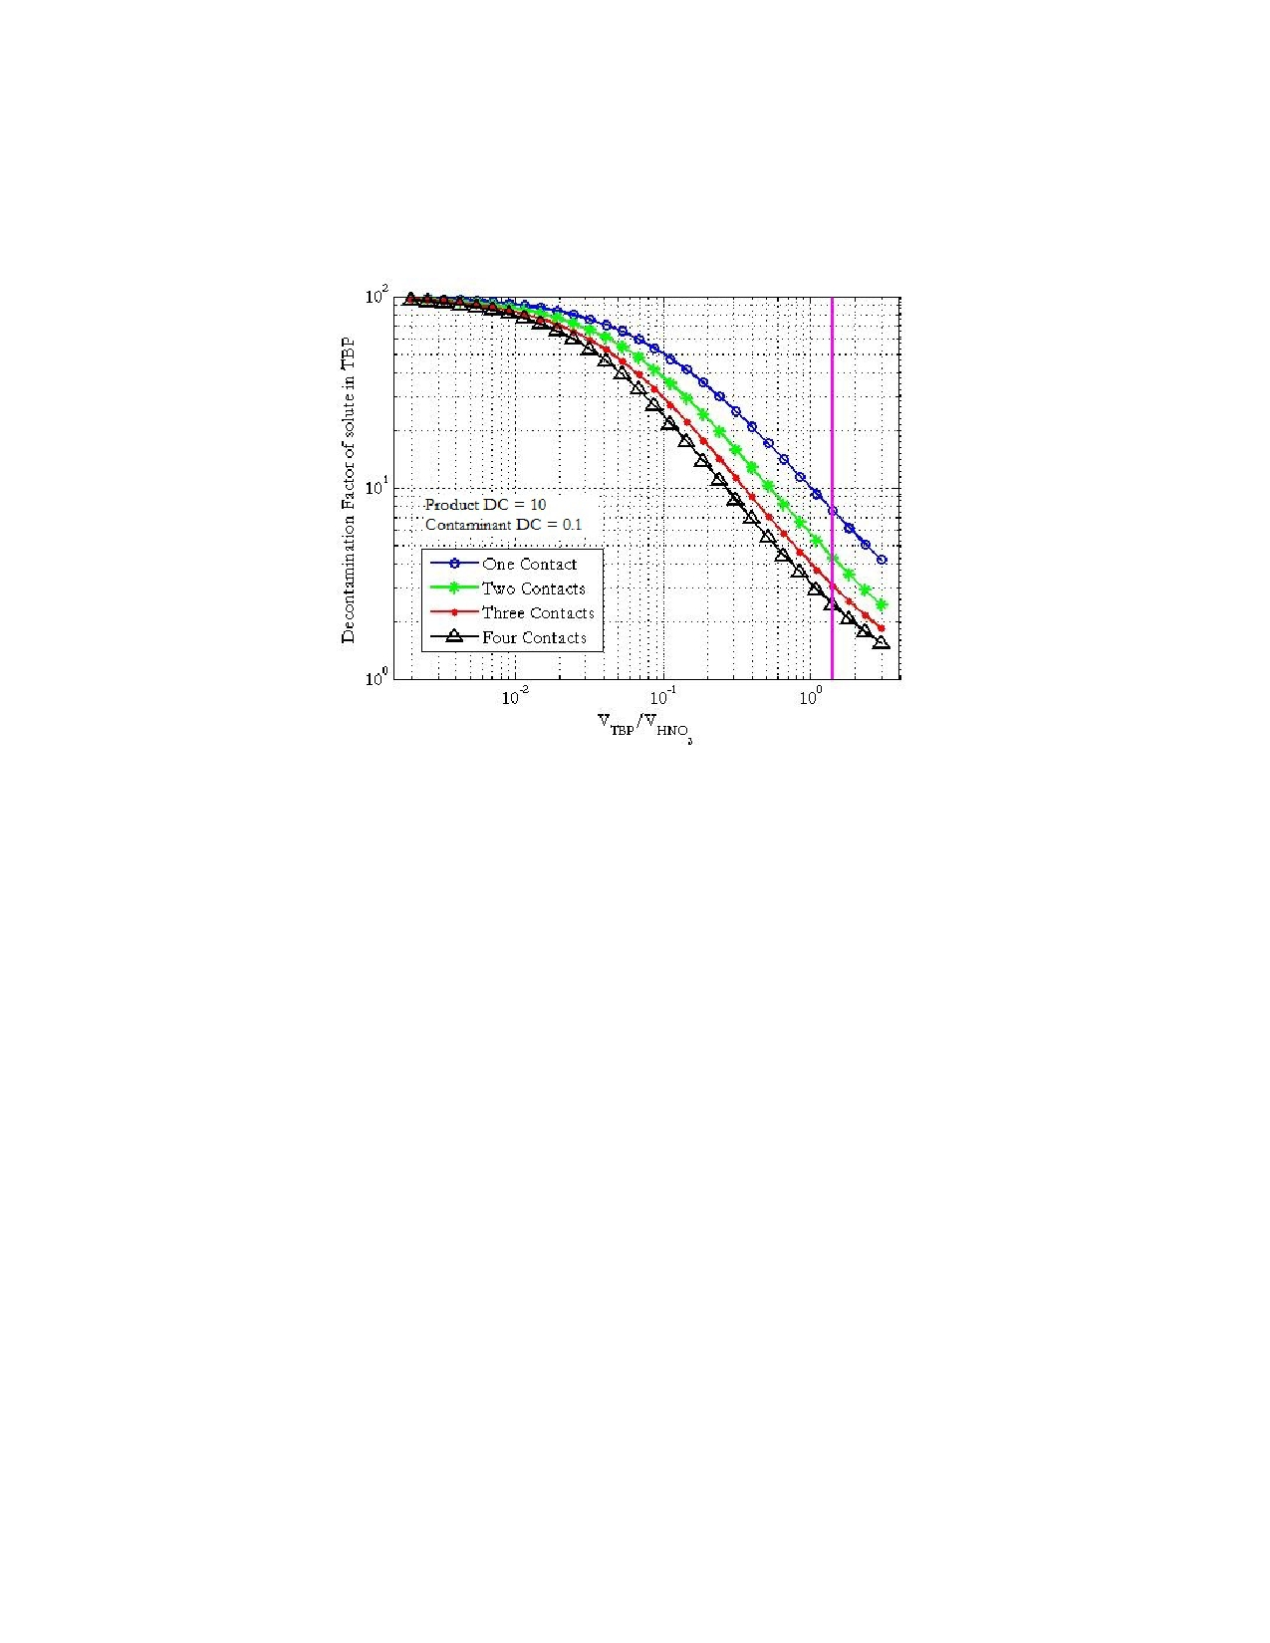

Figure 2: DFs as a function of volume ratios for the first to fourth contact in TBP.

170

175

180

calculated with the assumption that the DC for both the extraction and back-

extraction are equal. Simulating these experiments and plotting DC versus DF

is shown in Figure 3. The ratio of the DF for the second experiment and first

is about 0.30. Which means that the second experiment DF value should be no

better than 30% of the first experiment. Looking back to Table 2, the ratio of

the DF values between the second and first experiments, excluding U, is 0.27,

with values above and below.

**4. Conclusions**

Two experiments were conducted to quantify DF values for a variety of

elements as well as extract a large fraction of Pu. It was determined that the

volume ratio between organic and aqueous phases in extraction have an impact

on DF values, and that multiple extraction steps lead to large product recovery,

10

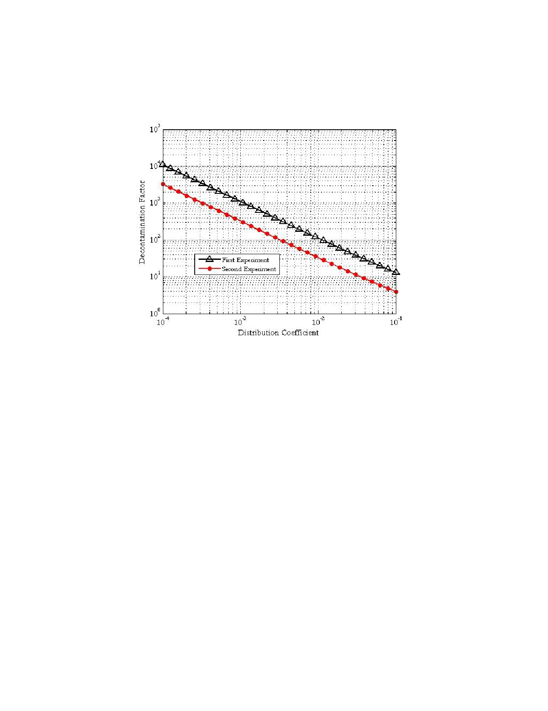

Figure 3: Decontamination factors as a function of Distribution Coefficient for the first and second experiment.

but can also decrease DF values. Future experiments will utilize a scrubbing

stage in the PUREX process.

[31, 32].

185

190

**References**

[1] S. S. Chirayath, J. M. Osborn, T. M. Coles, [Trace fission product](http://lib-ezproxy.tamu.edu:2048/login?url=http://search.ebscohost.com/login.aspx?direct=true&db=tsh&AN=101449802&site=eds-live)

[ratios for nuclear forensics attribution of weapons-grade plutonium](http://lib-ezproxy.tamu.edu:2048/login?url=http://search.ebscohost.com/login.aspx?direct=true&db=tsh&AN=101449802&site=eds-live)

[from fast and thermal reactors,](http://lib-ezproxy.tamu.edu:2048/login?url=http://search.ebscohost.com/login.aspx?direct=true&db=tsh&AN=101449802&site=eds-live) Science Global Security 23 (1) (2015)

48-67, science Global Security Authors: Chirayath, Sunil S. 1 Osborn,

Jeremy M. 1 Coles, Taylor M. 1; Afliations: 1: Nuclear Security Sci-

ence and Policy Institute, Texas AM University, College Station, TX,

USA; Subject: GEOTHERMAL reactors; Subject: FISSION products;

11

Subject: RADIOACTIVE substances; Subject: NUCLEAR fission;



Subject: PLUTONIUM; Subject: TERRORISM; Number of Pages: 20p.

195 [doi:10.1080/08929882.2015.996079.](http://dx.doi.org/10.1080/08929882.2015.996079)

URL [http://lib-ezproxy.tamu.edu:2048/login?url=http:](http://lib-ezproxy.tamu.edu:2048/login?url=http://search.ebscohost.com/login.aspx?direct=true&db=tsh&AN=101449802&site=eds-live)

[//search.ebscohost.com/login.aspx?direct=true&db=tsh&AN=](http://lib-ezproxy.tamu.edu:2048/login?url=http://search.ebscohost.com/login.aspx?direct=true&db=tsh&AN=101449802&site=eds-live)

[101449802&site=eds-live](http://lib-ezproxy.tamu.edu:2048/login?url=http://search.ebscohost.com/login.aspx?direct=true&db=tsh&AN=101449802&site=eds-live)

[2] W. Reas, [The purex process-a solvent extraction reprocessing method](http://lib-ezproxy.tamu.edu:2048/login?url=http://search.ebscohost.com/login.aspx?direct=true&db=edsstc&AN=4341712&site=eds-live)

200 [for irradiated uranium,](http://lib-ezproxy.tamu.edu:2048/login?url=http://search.ebscohost.com/login.aspx?direct=true&db=edsstc&AN=4341712&site=eds-live) accession Number: 4341712; Publication Type:

Report; Language: English; Publication Date: 19570401 (1957).

[doi:10.2172/4341712.](http://dx.doi.org/10.2172/4341712)

URL [http://lib-ezproxy.tamu.edu:2048/login?url=http:](http://lib-ezproxy.tamu.edu:2048/login?url=http://search.ebscohost.com/login.aspx?direct=true&db=edsstc&AN=4341712&site=eds-live)

205

[//search.ebscohost.com/login.aspx?direct=true&db=edsstc&AN=](http://lib-ezproxy.tamu.edu:2048/login?url=http://search.ebscohost.com/login.aspx?direct=true&db=edsstc&AN=4341712&site=eds-live)

[4341712&site=eds-live](http://lib-ezproxy.tamu.edu:2048/login?url=http://search.ebscohost.com/login.aspx?direct=true&db=edsstc&AN=4341712&site=eds-live)

[3] S. Stoller, R. Richards, Reactor handbook, volume ii, fuel reprocessing,

Inter science Publishers, Inc., New York.

[4] M. Benedict, H. Levi, T. Pigford, Nuclear chemical engineering, Nucl. Sci.

Eng. 82 (4).

210

215

[5] W. B. L. Gresky, A. T., Purex process laboratory development, Oak Ridge

National Laboratory USAEC Report ORNL-717.

[6] A. J. Arker, Terminal report on purex program in kapl separations pilot

plant, Knolls Atomic Power Laboratory.

[7] D. O. D. Chandler, J. M., Terminal report for the ornl pilot plant investiga-

tion of the purex process, Oak Ridge National Laboratory USAEC Report

ORNL -1519.

12

[8] W. Prout, [Equilibrium distribution ddata for purex and similar ex-](http://lib-ezproxy.tamu.edu:2048/login?url=http://search.ebscohost.com/login.aspx?direct=true&db=edsstc&AN=4317763&site=eds-live)



[traction processes,](http://lib-ezproxy.tamu.edu:2048/login?url=http://search.ebscohost.com/login.aspx?direct=true&db=edsstc&AN=4317763&site=eds-live) accession Number: 4317763; Publication Type:

Report; Language: English; Publication Date: 19570701 (1957).

220 [doi:10.2172/4317763.](http://dx.doi.org/10.2172/4317763)

URL [http://lib-ezproxy.tamu.edu:2048/login?url=http:](http://lib-ezproxy.tamu.edu:2048/login?url=http://search.ebscohost.com/login.aspx?direct=true&db=edsstc&AN=4317763&site=eds-live)

[//search.ebscohost.com/login.aspx?direct=true&db=edsstc&AN=](http://lib-ezproxy.tamu.edu:2048/login?url=http://search.ebscohost.com/login.aspx?direct=true&db=edsstc&AN=4317763&site=eds-live)

[4317763&site=eds-live](http://lib-ezproxy.tamu.edu:2048/login?url=http://search.ebscohost.com/login.aspx?direct=true&db=edsstc&AN=4317763&site=eds-live)

[9] K. Alcock, F. Bedford, W. Hardwick, H. McKay, Tri-n-butyl phosphate as

225

an extracting solvent for inorganic nitratesi: Zirconium nitrate, Journal of

Inorganic and Nuclear Chemistry 4 (2) (1957) 100-105.

[10] G. Best, H. McKay, P. Woodgate, Tri-n-butyl phosphate as an extracting

solvent for inorganic nitratesiii the plutonium nitrates, Journal of Inorganic

and Nuclear Chemistry 4 (5) (1957) 315-320.

230

235

[11] E. Hesford, H. McKay, D. Scargill, Tri-n-butyl phosphate as an extracting

solvent for inorganic nitratesiv thorium nitrate, Journal of Inorganic and

Nuclear Chemistry 4 (5) (1957) 321-325.

[12] D. Scargill, K. Alcock, J. Fletcher, E. Hesford, H. McKay, Tri-n-butyl

phosphate as an extracting solvent for inorganic nitratesii yttrium and the

lower lanthanide nitrates, Journal of Inorganic and Nuclear Chemistry 4 (5)

(1957) 304-314.

[13] K. Alcock, G. Best, E. Hesford, H. McKay, Tri-n-butyl phosphate as an

extracting solvent for inorganic nitratesv: Further results for the tetra-and

hexavalent actinide nitrates, Journal of Inorganic and Nuclear Chemistry

240 6 (4) (1958) 328-333.

[14] G. Best, E. Hesford, H. McKay, Tri-n-butyl phosphate as an extracting

13

agent for inorganic nitratesvii: The trivalent actinide nitrates, Journal of



Inorganic and Nuclear Chemistry 12 (1) (1959) 136-140.

[15] E. Hesford, E. Jackson, H. McKay, Tri-n-butyl phosphate as an extracting

245

250

agent for inorganic nitratesvi further results for the rare earth nitrates,

Journal of Inorganic and Nuclear Chemistry 9 (3-4) (1959) 279-289.

[16] A. P. Colburn, [Simplified calculation of difusional processes,](http://lib-ezproxy.tamu.edu:2048/login?url=http://search.ebscohost.com/login.aspx?direct=true&db=ast&AN=514845228&site=eds-live) general

consideration of two-film resistances 35 (1939) 211-236, transactions of

the American Institute of Chemical Engineers AuthorsColburn, A. P.;

Physical Description:Bibliography; Subject: CHEMICAL engineering -

Tables, calculations, etc; Subject: Difusion; Subject: Distillation; Subject:

Extraction processes; Subject: Heat transmission; Subject: Absorption;

Number of Pages: 26p; Record Type: Article.

URL [http://lib-ezproxy.tamu.edu:2048/login?url=http:](http://lib-ezproxy.tamu.edu:2048/login?url=http://search.ebscohost.com/login.aspx?direct=true&db=ast&AN=514845228&site=eds-live)

255

260

[//search.ebscohost.com/login.aspx?direct=true&db=ast&AN=](http://lib-ezproxy.tamu.edu:2048/login?url=http://search.ebscohost.com/login.aspx?direct=true&db=ast&AN=514845228&site=eds-live)

[514845228&site=eds-live](http://lib-ezproxy.tamu.edu:2048/login?url=http://search.ebscohost.com/login.aspx?direct=true&db=ast&AN=514845228&site=eds-live)

[17] T. K. Sherwood, R. L. Pigford, [Absorption and extraction. 2d ed,](http://lib-ezproxy.tamu.edu:2048/login?url=http://search.ebscohost.com/login.aspx?direct=true&db=cat03318a&AN=tamug.107458&site=eds-live)

Chemical engineering series, New York : McGraw-Hill, 1952. 2d ed., 1952,

evans/Annex TP156.A3 S5 1952 Accession Number: tamug.107458; Other

Notes: Bibliography: pages 455-469.; Publication Type: Book; Physical

Description: 478 pages; Language: English; LCCN: 51012644; OCLC:

00567332.

URL [http://lib-ezproxy.tamu.edu:2048/login?url=http:](http://lib-ezproxy.tamu.edu:2048/login?url=http://search.ebscohost.com/login.aspx?direct=true&db=cat03318a&AN=tamug.107458&site=eds-live)

265

[//search.ebscohost.com/login.aspx?direct=true&db=cat03318a&](http://lib-ezproxy.tamu.edu:2048/login?url=http://search.ebscohost.com/login.aspx?direct=true&db=cat03318a&AN=tamug.107458&site=eds-live)

[AN=tamug.107458&site=eds-live](http://lib-ezproxy.tamu.edu:2048/login?url=http://search.ebscohost.com/login.aspx?direct=true&db=cat03318a&AN=tamug.107458&site=eds-live)

[18] J. T. Long, [Engineering for nuclear fuel reprocessing,](http://lib-ezproxy.tamu.edu:2048/login?url=http://search.ebscohost.com/login.aspx?direct=true&db=cat03318a&AN=tamug.711551&site=eds-live) New York : Gordon

and Breach Science Publishers, [1967], 1967, evans/Annex TK9360 .L65

14



270

Accession Number: tamug.711551; Other Notes: "Prepared under the

auspices of Division of Technical Information, United States Atomic

Energy Commission."; Includes bibliographies.; Publication Type: Book;

Physical Description: ix, 1023 pages : illustrations ; 24 cm.; Language:

English; LCCN: 66028071; OCLC: 00783040.

URL [http://lib-ezproxy.tamu.edu:2048/login?url=http:](http://lib-ezproxy.tamu.edu:2048/login?url=http://search.ebscohost.com/login.aspx?direct=true&db=cat03318a&AN=tamug.711551&site=eds-live)

275

280

[//search.ebscohost.com/login.aspx?direct=true&db=cat03318a&](http://lib-ezproxy.tamu.edu:2048/login?url=http://search.ebscohost.com/login.aspx?direct=true&db=cat03318a&AN=tamug.711551&site=eds-live)

[AN=tamug.711551&site=eds-live](http://lib-ezproxy.tamu.edu:2048/login?url=http://search.ebscohost.com/login.aspx?direct=true&db=cat03318a&AN=tamug.711551&site=eds-live)

[[19]](http://lib-ezproxy.tamu.edu:2048/login?url=http://search.ebscohost.com/login.aspx?direct=true&db=cat03318a&AN=tamug.3756052&site=eds-live%20http://lib-ezproxy.tamu.edu:2048/login?url=http://site.ebrary.com/lib/tamu/docDetail.action?docID=10211725) R. H. Perry, D. W. Green, [Perry's chemical engineers' handbook. 8th](http://lib-ezproxy.tamu.edu:2048/login?url=http://search.ebscohost.com/login.aspx?direct=true&db=cat03318a&AN=tamug.3756052&site=eds-live%20http://lib-ezproxy.tamu.edu:2048/login?url=http://site.ebrary.com/lib/tamu/docDetail.action?docID=10211725)

[ed,](http://lib-ezproxy.tamu.edu:2048/login?url=http://search.ebscohost.com/login.aspx?direct=true&db=cat03318a&AN=tamug.3756052&site=eds-live%20http://lib-ezproxy.tamu.edu:2048/login?url=http://site.ebrary.com/lib/tamu/docDetail.action?docID=10211725) New York : McGraw-Hill, [2008] 8th ed. / prepared by a staf of

specialists under the editorial direction of editor-in-chief, Don W. Green,

late editor, Robert H. Perry., 2008, available Online TP151 .P45 2008eb

Accession Number: tamug.3756052; Corporate Authors: ebrary, Inc.;

Other Notes: Electronic resource.; Includes bibliographical references and

index.; Electronic reproduction. Palo Alto, Calif. : ebrary, 2009. Available

via World Wide Web. Access may be limited to ebrary afliated libraries.;

Publication Type: Book, eBook; Physical Description: 1 volume (various

285 pagings) : illustrations ; 27 cm.; Language: English.

URL [http://lib-ezproxy.tamu.edu:2048/login?url=http:](http://lib-ezproxy.tamu.edu:2048/login?url=http://search.ebscohost.com/login.aspx?direct=true&db=cat03318a&AN=tamug.3756052&site=eds-live%20http://lib-ezproxy.tamu.edu:2048/login?url=http://site.ebrary.com/lib/tamu/docDetail.action?docID=10211725)

[//search.ebscohost.com/login.aspx?direct=true&db=cat03318a&](http://lib-ezproxy.tamu.edu:2048/login?url=http://search.ebscohost.com/login.aspx?direct=true&db=cat03318a&AN=tamug.3756052&site=eds-live%20http://lib-ezproxy.tamu.edu:2048/login?url=http://site.ebrary.com/lib/tamu/docDetail.action?docID=10211725)

[AN=tamug.3756052&site=eds-livehttp://lib-ezproxy.tamu.edu:](http://lib-ezproxy.tamu.edu:2048/login?url=http://search.ebscohost.com/login.aspx?direct=true&db=cat03318a&AN=tamug.3756052&site=eds-live%20http://lib-ezproxy.tamu.edu:2048/login?url=http://site.ebrary.com/lib/tamu/docDetail.action?docID=10211725)

[2048/login?url=http://site.ebrary.com/lib/tamu/docDetail.](http://lib-ezproxy.tamu.edu:2048/login?url=http://search.ebscohost.com/login.aspx?direct=true&db=cat03318a&AN=tamug.3756052&site=eds-live%20http://lib-ezproxy.tamu.edu:2048/login?url=http://site.ebrary.com/lib/tamu/docDetail.action?docID=10211725)

290 [action?docID=10211725](http://lib-ezproxy.tamu.edu:2048/login?url=http://search.ebscohost.com/login.aspx?direct=true&db=cat03318a&AN=tamug.3756052&site=eds-live%20http://lib-ezproxy.tamu.edu:2048/login?url=http://site.ebrary.com/lib/tamu/docDetail.action?docID=10211725)

[20] E. Collins, D. Campbell, L. Felker, Measurement of achievable pluto-

nium decontamination from gallium by means of purex solvent extraction,

ORNL/TM-1999/312, Oak Ridge National Laboratory.

15

[21] F. S. Michael, D. L. Jack, Nuclear fuel reprocessing - inl/ext-10-17753



295

300

(2010). [doi:10.2172/974763.](http://dx.doi.org/10.2172/974763)

[22] M. Swinney, Experimental and computational assessment of trace nuclide

ratios in weapons grade plutonium for nuclear forensics analysis, Ph.D.

thesis, Texas AM University (2016).

[[23]](http://www.sciencelab.com/) Chemicals and Laboratory Equipment, howpublished = [http://www.](http://www.sciencelab.com/)

[sciencelab.com/,](http://www.sciencelab.com/) note = Accessed: 2016-02-15.

[[24]](http://www.mallinckrodt.com//) Mallinckrodt Pharmaceuticals, howpublished = [http://www.](http://www.mallinckrodt.com//)

[mallinckrodt.com//,](http://www.mallinckrodt.com//) note = Accessed: 2016-02-15.

[[25]](https://www.fishersci.com/us/en/home.html) Fisher Scientific, howpublished = [https://www.fishersci.com/us/en/](https://www.fishersci.com/us/en/home.html)

[home.html,](https://www.fishersci.com/us/en/home.html) note = Accessed: 2016-02-15.

305

[26] Strem Chemicals Incorporation, howpublished = [http://www.strem.com/,](http://www.strem.com/)

note = Accessed: 2016-02-15.

[[27]](http://www.canberra.com/products/detectors/pdf/sege-detectors-c40021.pdf) Standard Electrode Coaxial Ge Detectors, howpublished = [http://www.](http://www.canberra.com/products/detectors/pdf/sege-detectors-c40021.pdf)

[canberra.com/products/detectors/pdf/sege-detectors-c40021.pdf,](http://www.canberra.com/products/detectors/pdf/sege-detectors-c40021.pdf)

note = Accessed: 2016-02-15.

310

315

[[28]](http://www.canberra.com/products/radiochemistry_lab/pdf/lynx-ss-c38658.pdf) Lynx Digital Signal Analyzer, howpublished = [http://www.canberra.](http://www.canberra.com/products/radiochemistry_lab/pdf/lynx-ss-c38658.pdf)

[com/products/radiochemistry_lab/pdf/lynx-ss-c38658.pdf,](http://www.canberra.com/products/radiochemistry_lab/pdf/lynx-ss-c38658.pdf) note =

Accessed: 2016-02-15.

[29] G.-P. Version, 2.1 users manual, volumes 1 and 2, Canberra Nuclear.

[30] Perkin Elmer Inc. and NexION 300 ICP-MS Instruments kernel

description, [http://www.perkinelmer.com/Catalog/Family/ID/NexION,](http://www.perkinelmer.com/Catalog/Family/ID/NexION)

accessed: 2015-09-30.

16

[31] R. Feynman, F. Vernon Jr., The theory of a general quantum system in-



teracting with a linear dissipative system, Annals of Physics 24 (1963)

118-173. [doi:10.1016/0003-4916(63)90068-X.](http://dx.doi.org/10.1016/0003-4916(63)90068-X)

320 [32] P. Dirac, The lorentz transformation and absolute time, Physica 19 (1-12)

(1953) 888-896. [doi:10.1016/S0031-8914(53)80099-6.](http://dx.doi.org/10.1016/S0031-8914(53)80099-6)

17